Writing Python Programs to simulate Logic Circuits – sheet 2

**Example:**

Read the following example, then follow the same principle to complete the other questions.

A water pump is being designed that will only pump when the main switch (A) is on and there is water present in the system (sensor B).

|  |  |  |
| --- | --- | --- |
| A | B | C |
| 0 | 0 | 0 |
| 0 | 1 | 0 |
| 1 | 0 | 0 |
| 1 | 1 | 1 |

Draw the logic diagram to show this and complete the truth table. 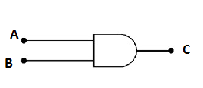

A program in Python that simulates the case above is given below :

**A = input ("Is the main switched on? type yes or no")**

**B = input ("Enter B is the water present type yes or no")**

**if (A== "yes") and (B == "yes"):**

**print ("Pump is ON")**

**else:**

**print ("Pump is OFF")**

Check the code using Python and compare with the truth table.

Now answer the following questions:

1. An intruder alarm system uses an IR motion sensor (A) and a magnetic door alarm (B). The alarm should be sounded if either sensor is triggered.

Draw the logic diagram to show this and complete the truth table.

Write Python program to simulate this scenario.

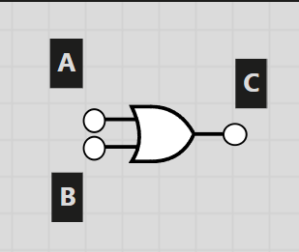

a=input("Enter is sensor A detected? yes/no")  
b=input("Enter is sensor B detected? yes/no")  
  
if (a=="yes") or (b=="yes"):  
 print("Alarm on")  
else:  
 print("Alarm off")

1. A kettle element should be turned on provided the main switch (A) is on and the temperature sensor (B) is not indicating a temperature of over 100 degrees.

A) Draw the **logic circuit diagram** to show this and complete the **truth table**.

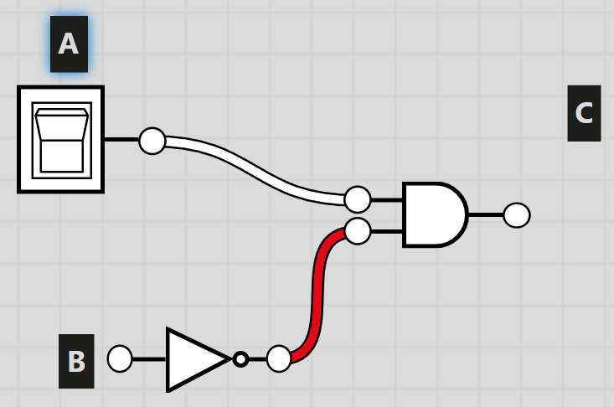

B) Write Python program to simulate this logic circuit .

1. write an equivalent Python programs to the following logic circuit.

